**Experiment 5: Implement Multiplication Table Generator and Interest Calculator Using JavaScript.**

|  |  |  |  |
| --- | --- | --- | --- |
|  | **Course Name: Web Technology Lab** | **EXPERIMENT NO. 5** | |
| **Course Code: 23CP306P**  **Faculty: Punit Gupta** | **Branch: CSE** | **Semester: V** |

Experiment 5: Implement Multiplication Table Generator and Interest Calculator Using JavaScript.

**Code: practicals.html**

|  |
| --- |
| <html>  <head>  <link rel="stylesheet" href="style.css">  </head>  <body >  <header>  <div class="home-div">  <img src="3.jpg" alt="Joeli Icon" width="35" height="35" class="icon">  <h2 class="nightcode">NightCode ✨</h2>  </div>  <nav>  <a href="home.html">Home</a>  <a href="about.html" >About</a>  <a href="media.html" >Media</a>  <a href="profile.html" >Profile</a>  <a href="Signin.html" >Sign In</a>  <a href="review.html" >Feedback</a>  <a href="practicals.html">Practicals</a>  </nav>  </header>  <div id="div-intro">  <h1>Practicals</h1>  <p>Select a practical to perform:</p>  <ul>  <li><a href="multiplication.html">Multiplication Table</a></li>  <li><a href="interest.html">Interest Calculator</a></li>  </ul>  </div>  <footer>  <p>This page is part of Experiment 5. Created by Priyanshi Pankhaniya (23BCP507D).</p>  </footer>  </body>  </html> |

**Output:** 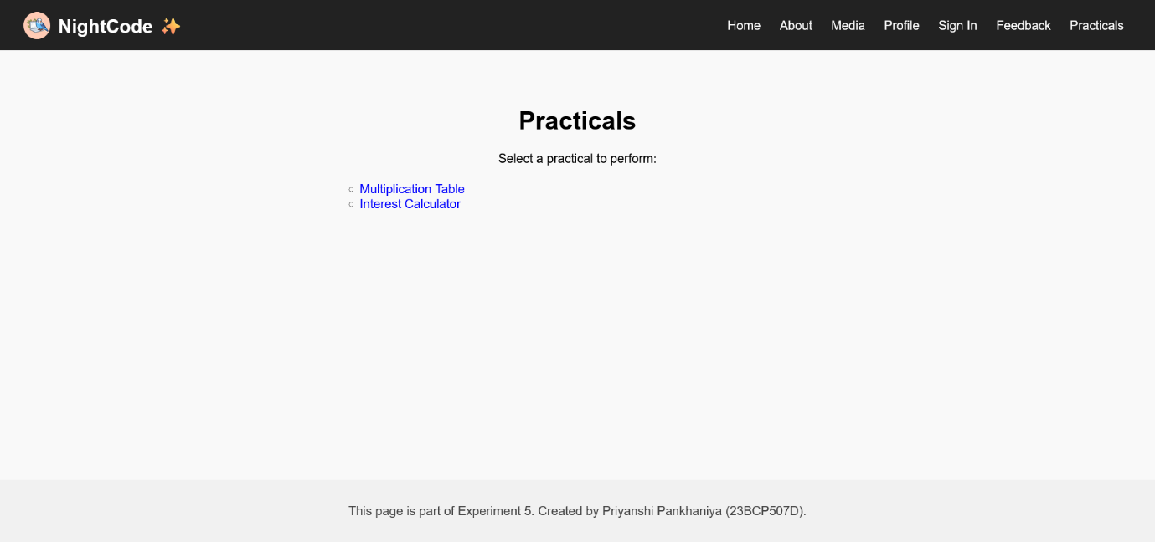

practicals.html

**Code: multiplication.html**

|  |
| --- |
| <html>  <head>  <title>Multiplication Table</title>  <link rel="stylesheet" href="style.css">  </head>  <body>  <header>  <div class="home-div">  <img src="3.jpg" alt="Joeli Icon" width="35" height="35" class="icon">  <h2 class="nightcode">NightCode ✨</h2>  </div>  <nav>  <a href="home.html">Home</a>  <a href="about.html">About</a>  <a href="media.html">Media</a>  <a href="profile.html">Profile</a>  <a href="Signin.html">Sign In</a>  <a href="review.html">Feedback</a>  <a href="practicals.html">Practicals</a>  </nav>  </header>  <div id="div-intro">  <center>  <form>  <fieldset>  <legend>Multiplication Table</legend>  <label for="num">Enter Number:</label>  <input type="number" id="num"><br><br>  <button type="button" onclick="print()">Generate Table</button>  </fieldset>  </form>  </center>  <div id="result" style="margin-top:20px; font-weight:bold;"></div>  </div>  <footer>  <p>This page is part of Experiment 5. Created by Priyanshi Pankhaniya (23BCP507D).</p>  </footer>  <script>  function print()  {  let num= parseInt(document.getElementById("num").value);  let text = "";  for (let i = 1; i <= 10; i++) {  text += num + " × " + i + " = " + (num * i) + "<br>";  }  document.getElementById("result").innerHTML = text;  }  </script>  </script>  </body>  </html> |

multiplication.html

**Code: interest.html**

|  |
| --- |
| <html>  <head>  <title>Interest Calculator</title>  <link rel="stylesheet" href="style.css">  </head>  <body>  <header>  <div class="home-div">  <img src="3.jpg" alt="Joeli Icon" width="35" height="35" class="icon">  <h2 class="nightcode">NightCode ✨</h2>  </div>  <nav>  <a href="home.html">Home</a>  <a href="about.html">About</a>  <a href="media.html">Media</a>  <a href="profile.html">Profile</a>  <a href="Signin.html">Sign In</a>  <a href="review.html">Feedback</a>  <a href="practicals.html">Practicals</a>  </nav>  </header>  <div id="div-intro">  <center>  <form>  <fieldset>  <legend>Interest Calculator</legend>  <label>Principal (₹): <span id="pVal">5000</span></label><br>  <input type="range" id="principal" min="1000" max="100000" step="1000" value="5000" onchange="calculateInterest()" oninput="updateDisplay()"><br><br>  <label>Rate (%): <span id="rVal">5</span></label><br>  <input type="range" id="rate" min="1" max="20" step="0.5" value="5" onchange="calculateInterest()" oninput="updateDisplay()"><br><br>  <label>Time (Years): <span id="tVal">1</span></label><br>  <input type="range" id="time" min="1" max="30" step="1" value="1" onchange="calculateInterest()" oninput="updateDisplay()"><br><br>  </fieldset>  </form>  </center>  <div id="result" style="margin-top:20px; font-weight:bold;"></div>  </div>  <script>  function updateDisplay() {  document.getElementById('pVal').textContent = document.getElementById('principal').value;  document.getElementById('rVal').textContent = document.getElementById('rate').value;  document.getElementById('tVal').textContent = document.getElementById('time').value;  }  function calculateInterest() {  const p = parseFloat(document.getElementById('principal').value);  const r = parseFloat(document.getElementById('rate').value);  const t = parseFloat(document.getElementById('time').value);  const si = (p * r * t) / 100;  const total = p + si;  document.getElementById('result').innerHTML =  `Simple Interest: ₹${si.toFixed(2)}<br>Total Amount: ₹${total.toFixed(2)}`;  }  updateDisplay();  calculateInterest();  </script>  <footer>  <p>This page is part of Experiment 5. Created by Priyanshi Pankhaniya (23BCP507D).</p>  </footer>  </body>  </html> |

interest.html